APPLICATION for "90 YEARS OF RADIO CLUB" ZAGREB AWARD

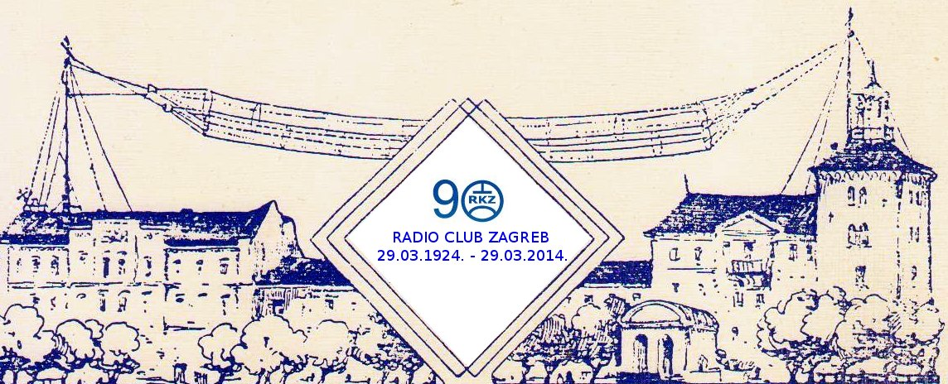
Radio Club Zagreb
Trg zrtava fasizma 14
10000 Zagreb
C R O A T I A

Call:
Name:
Address:

I apply for "90 YEARS OF RADIO CLUB ZAGREB" Award with following QSO' s.

Nr. | Call | Date | Time | Band | Mode | Rx-RSQ | Tx-RSQ
1.
2.
3.
4.
5.
6.
7.
8.
9.
10.

Date:

Award Manager: Boris Lanca 9A2GA borislanca@gmail.com

